Artificial Intelligence: examples of ethical dilemmas

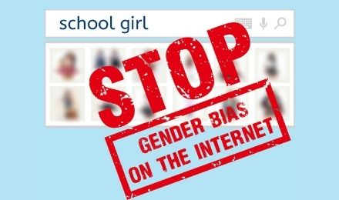

[Biased AI](https://en.unesco.org/artificial-intelligence/ethics/cases#biasedai)



[Autonomous car](https://en.unesco.org/artificial-intelligence/ethics/cases#autonomouscar)

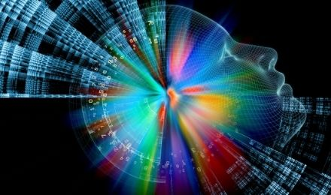

[AI creates art](https://en.unesco.org/artificial-intelligence/ethics/cases#art)

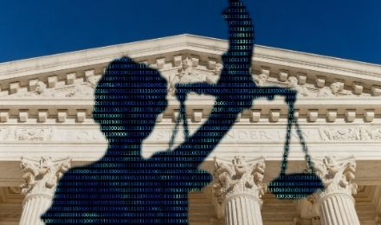

[AI in the Court of Law](https://en.unesco.org/artificial-intelligence/ethics/cases#law)

**Biased AI**

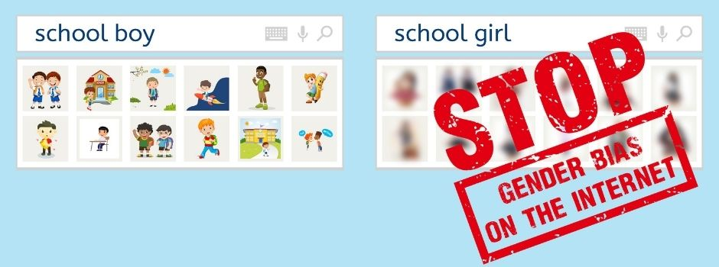

© UNESCO

Type “greatest leaders of all time” in your favourite search engine and you will probably see a list of the world’s prominent male personalities. How many women do you count?

An image search for “school girl” will most probably reveal a page filled with women and girls in all sorts of sexualised costumes. Surprisingly, if you type “school boy”, results will mostly show ordinary young school boys. No men in sexualised costumes or very few.

These are examples of gender bias in artificial intelligence, originating from stereotypical representations deeply rooted in our societies.

AI-systems deliver biased results. Search-engine technology is not neutral as it processes big data and prioritises results with the most clicks relying both on user preferences and location. Thus, a search engine can become an echo chamber that upholds biases of the real world and further entrenches these prejudices and stereotypes online.

How can we ensure more equalised and accurate results? Can we report biased search results? What would or should be the accurate representation of women in search results?

Gender bias should be avoided or at the least minimized in the development of algorithms, in the large data sets used for their learning, and in AI use for decision-making.

To not replicate stereotypical representations of women in the digital realm, UNESCO wants to address gender bias in AI.

**That is why UNESCO has embarked for the first time to develop**[**a legal, global document on the ethics of AI**](https://en.unesco.org/artificial-intelligence/ethics)**.**

**Everyone and every part of the world should be part of this debate. Artificial Intelligence is everyone’s business!**

* To learn more about the ethics of artificial intelligence : [Preliminary study on the Ethics of Artificial Intelligence (COMEST)](https://unesdoc.unesco.org/ark:/48223/pf0000367823)

**Autonomous car**



© Shutterstock.com/Senha

**An autonomous car is a vehicle that is capable of sensing its environment and moving with little or no human involvement. For the vehicle to move safely and to understand its driving environment, an enormous amount of data needs to be captured by myriad different sensors across the car at all time. These are then processed by the vehicle’s autonomous driving computer system.**

The autonomous car must also undertake a considerable amount of training in order to understand the data it is collecting and to be able to make the right decision in any imaginable traffic situation.

Moral decisions are made by everyone daily. When a driver chooses to slam on the brakes to avoid hitting a jaywalker, they are making the moral decision to shift risk from the pedestrian to the people in the car.

Imagine an autonomous car with broken brakes going at full speed towards a grand-mother and a child. By deviating a little, one can be saved.

This time, it is not a human driver who is going to take the decision, but the car’s algorithm.

Who would you choose, the grandmother or the child? Do you think there is only one right answer?

This is a typical ethical dilemma, that shows the importance of ethics in the development of technologies.

**That is why UNESCO has embarked for the first time to develop**[**a legal and global document on the ethics of AI**](https://en.unesco.org/artificial-intelligence/ethics)**.**

**Everyone and every part of the world should be part of this debate. Artificial Intelligence is everyone’s business!**

* To learn more on ethical dilemmas: [Moral Machine!(link is external)](https://moralmachine.mit.edu/) MIT Website with different scenarios
* Watch our video : ["Why is ethics crucial in the development of AI?"(link is external)](https://youtu.be/HzYG56HLxbI)
* To learn more about the ethics of artificial intelligence : [Preliminary study on the Ethics of Artificial Intelligence (COMEST)](https://unesdoc.unesco.org/ark:/48223/pf0000367823)

**AI creates art**

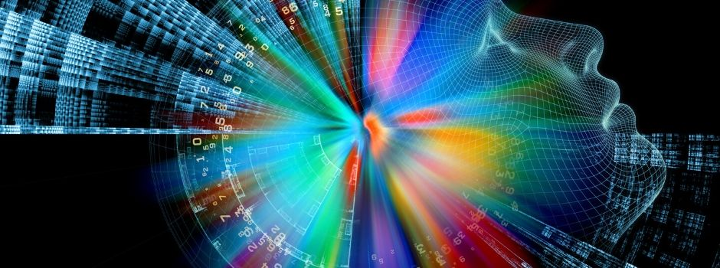

© Shutterstock.com/agsandrew

**The use of AI in culture raises interesting ethical reflections.**

**In 2016, a Rembrandt painting, “the Next Rembrandt”, was designed by a computer and created by a 3D printer, 351 years after the painter’s death.**

**To achieve such technological and artistic prowess, 346 Rembrandt paintings were analysed pixel by pixel and upscaled by deep learning algorithms to create a unique database. Every detail of Rembrandt’s artistic identity could then be captured and set the foundation for an algorithm capable of creating an unprecedented masterpiece. To bring the painting to life, a 3D printer recreated the texture of brushstrokes and layers of pain on the canvas for a breath-taking result that could trick any art expert.**

**But who can be designated as the author? The company which orchestrated the project, the engineers, the algorithm, or… Rembrandt himself?**

In 2019, the Chinese technology company Huawei announced that an AI algorithm has been able to complete the last two movements of Symphony No.8, the unfinished composition that Franz Schubert started in 1822, 197 years before. So what happens when AI has the capacity to create works of art itself? If a human author is replaced by machines and algorithms, to what extent copyrights can be attributed at all? Can and should an algorithm be recognized as an author, and enjoy the same rights as an artist?

Work of art produced by AI requires a new definition of what it means to be an “author”, in order to do justice to the creative work of both the “original” author and the algorithms and technologies that produced the work of art itself.

Creativity, understood as the capacity to produce new and original content through imagination or invention, plays a central role in open, inclusive and pluralistic societies. For this reason, the impact of AI on human creativity deserves careful attention. While AI is a powerful tool for creation, it raises important questions about the future of art, the rights and remuneration of artists and the integrity of the creative value chain.

We need to develop new frameworks to differentiate piracy and plagiarism from originality and creativity, and to recognize the value of human creative work in our interactions with AI. These frameworks are needed to avoid the deliberate exploitation of the work and creativity of human beings, and to ensure adequate remuneration and recognition for artists, the integrity of the cultural value chain, and the cultural sector’s ability to provide decent jobs.

**That is why UNESCO has embarked for the first time to develop**[**a legal and global document on the ethics of AI**](https://en.unesco.org/artificial-intelligence/ethics)**.**

**Everyone and every part of the world should be part of this debate. Artificial Intelligence is everyone’s business!**

* To learn more about [“the Next Rembrandt”(link is external)](https://www.nextrembrandt.com/)
* To learn more about the ethics of artificial intelligence : [Preliminary study on the Ethics of Artificial Intelligence (COMEST)](https://unesdoc.unesco.org/ark:/48223/pf0000367823)

**AI in the Court of Law**

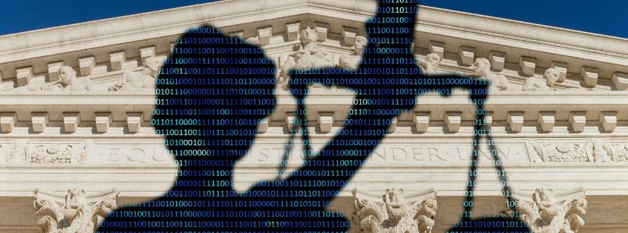

© Shutterstock.com/icedmocha

**The use of AI in judicial systems around the world is increasing, creating more ethical questions to explore. AI could presumably evaluate cases and apply justice in a better, faster, and more efficient way than a judge.**

AI methods can potentially have a huge impact in a wide range of areas, from the legal professions and the judiciary to aiding the decision-making of legislative and administrative public bodies. For example, they can increase the efficiency and accuracy of lawyers in both counselling and litigation, with benefits to lawyers, their clients and society as a whole. Existing software systems for judges can be complemented and enhanced through AI tools to support them in drafting new decisions. This trend towards the ever-increasing use of autonomous systems has been described as the automatization of justice.

Some argue that AI could help create a fairer criminal judicial system, in which machines could evaluate and weigh relevant factors better than human, taking advantage of its speed and large data ingestion. AI would therefore make decisions based on informed decisions devoid of any bias and subjectivity.

But there are many ethical challenges:

* Lack of transparency of AI tools: AI decisions are not always intelligible to humans.
* AI is not neutral: AI-based decisions are susceptible to inaccuracies, discriminatory outcomes, embedded or inserted bias.
* Surveillance practices for data gathering and privacy of court users.
* New concerns for fairness and risk for Human Rights and other fundamental values.

So, would you want to be judged by a robot in a court of law? Would you, even if we are not sure how it reaches its conclusions?

**That is why UNESCO has embarked for the first time to develop**[**a legal, global document on the ethics of AI**](https://en.unesco.org/artificial-intelligence/ethics)**.**

**Everyone and every part of the world should be part of this debate. Artificial Intelligence is everyone’s business!**

* To learn more about the ethics of artificial intelligence : [Preliminary study on the Ethics of Artificial Intelligence (COMEST)](https://unesdoc.unesco.org/ark:/48223/pf0000367823)

UNESCO applies a zero tolerance policy against all forms of harassment

* **.**